A000-Syro-Hittite-Astarte-Figurine-Female-Terracotta-Late Bronze Age-1500 - 1200 BCE

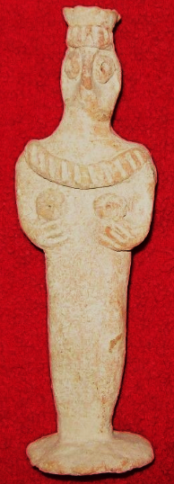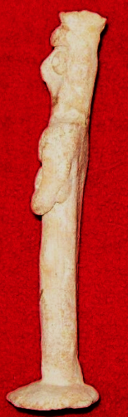

Figs. 1-2. Syro-Hittite-Astarte-Figurine-Female-Terracotta-Late Bronze Age-1500 - 1200 BCE

**Case no.: 3**

**Accession Number: 1345**

**Formal Label:** Syro-Hittite-Astarte-Figurine-Female-Terracotta-Late Bronze Age-1500 - 1200 BCE

**Display Description:**

This stylized figurine with flat violin-shaped body and bird-like face with a beak-like nose. An elaborate crown is constructed with an upright headpiece and an everted tiara. Two short arms are supporting breasts, which are marked by circular, punctated appliques. The eyes are constructed like the breasts with circular, punctated appliques. She wears a large necklace that falls off the shoulders. The body is cambered to appear slightly angled upwards at about 4 degrees, suggesting the figure is in a trance state and communicating with the spirit world (cf. Spycket, A., Borowski Collection, 2000, Cat. no. 84, p. 102, (photograph, p. 101), for the type with long arms; Keel, O., Freiburg, 2008, p. 23, fig 3).

**LC Classification:** BL1605 A5

**Date or Time Horizon:** Late Bronze Age-1500 - 1200 BCE

**Geographical Area:** N Syria, S Anatolia.

**Map, GPS coordinates:** N Syria, S Anatolia

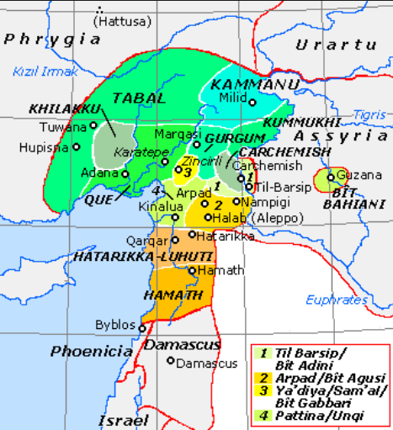

**Fig. 4.** Map of Luwian-, Aramaic- and Phoenician-speaking political entities of the the Syro-Hittite states in northern Syria and southern Anatolia from https://upload.wikimedia.org/wikipedia/commons/f/fe/NeoHittiteStates.gif.

**Cultural Affiliation:** Syro-Hittite

**Medium:** Terracotta

**Dimensions:** H. 13.4 cm., 5 1/4 in

**Weight: 49 gm, 1 1/8 oz**

**Condition: original**

**Provenance:** Ex. Private collection 1980's; Gideon Sasson, Sasson Ancient Art, King David Hotel - Annex, Jerusalem - 94101,  Israel.

Discussion:

**References:**

Cornelius, Izak. 2004. *The many faces of the goddess: the iconography of the Syro-Palestinian goddesses Anat, Astarte, Qedeshe.* Fribourg, Switzerland: Academic Press; Göttingen: Vandenhoeck & Ruprecht.

Keel, O. 2008. *Gott weiblich: Eine verborgene Seite des biblischen Gottes, Gutersloher Verlagshaus*. Freiburg.

Spycket, A. 2000. *The Human Form Divine. From the Collection of Elie Borowski,* Exh. cat., Jerusalem: Bible Lands Museum.